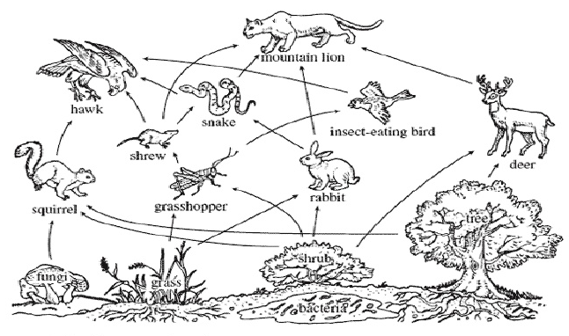
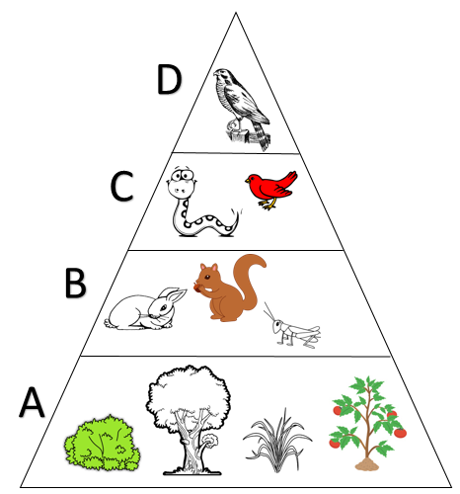

Food Web Questions
- What are the producers in this web?

- What are the primary consumers in this web?

- What are the secondary consumers in this web?

- What are the tertiary consumers in this web?

- Which consumers fit into more than one category above?

- What are the top predators in this food web?

- Are there any omnivores in this web?

- Predict what would happen if grasshoppers disappeared from the ecosystem.

- Predict what would happen if the population of deer increased in this ecosystem.

- Construct at least 5 food chains using this food web (there are at least 20, so I know you can do it!)

Ecological Pyramid Questions
- Label each layer of the ecological pyramid.

- Which layer would have the most organisms? Why?

- Which layer would have the least organisms? Why?

- Which layer would have the most energy? Why?

- Which layer would have the least energy? Why?

- How much energy from a layer is passed to the layer above it?

- Why doesn’t all of the energy from one layer make it to the one above it?

