[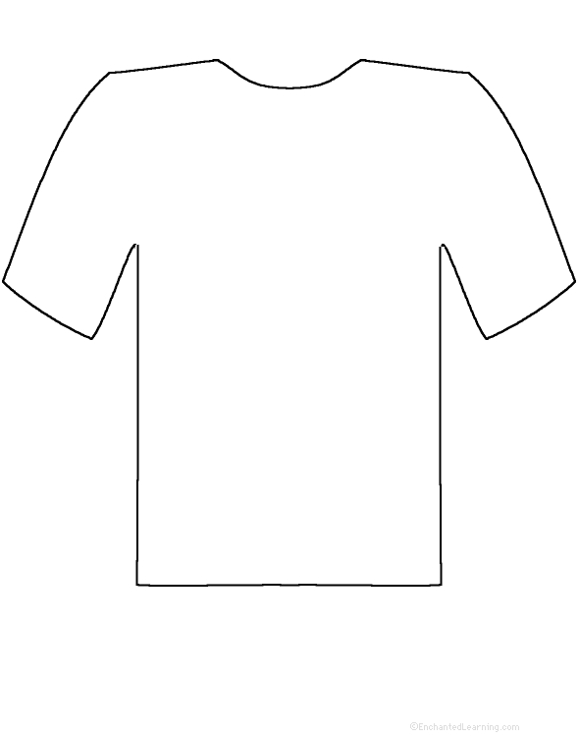](http://www.enchantedlearning.com/poetry/perimeterpoems/)

**Word _______________________________________**

**Definition__________________________________________**

**________________________________________________________________**

**___________________________________________________________________________**

Name: __________________________

Block: ___________