Populations Notes
What is a Population?
- All the members of a ________________ living in the same _________________ at the same _______________________.
- Examples: Palm trees on an island, a school of specific fish, and daisies in a field in Ohio.
Properties of Populations
- Population _________________-the number of _______________________ per unit area or volume
  - Example: the number of small mouth bass per cubic meter of water in a lake.
- ______________________- the relative distribution or ______________________ of its individuals within a given amount of space.
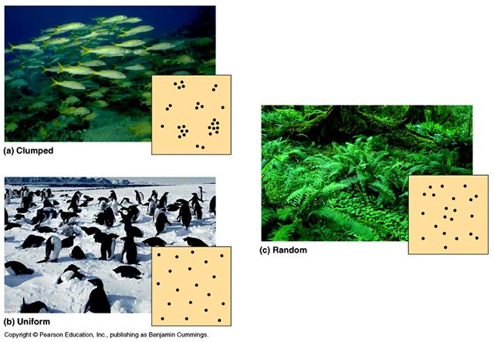

Clumped

Random

Uniform

How Does a Population Grow?
- Growth Rate-the ______________________ minus the _______________________ of a population.
- Change in population size = Births - Deaths
How Fast Can a Population Grow?
- __________________________________: The fastest rate at which its potential population can grow.
- Reproductive Potential: The _______________________ number of __________________________ that each member of the population can produce.
- If perfect conditions, it would take a pair of elephants _______________________ to produce 19 million descendants.

Exponential Growth
- A ___________________could produce 19 ____________________ new cells in a few days or weeks.
- ____________________ growth is an example of this.
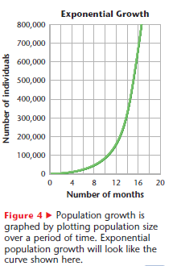
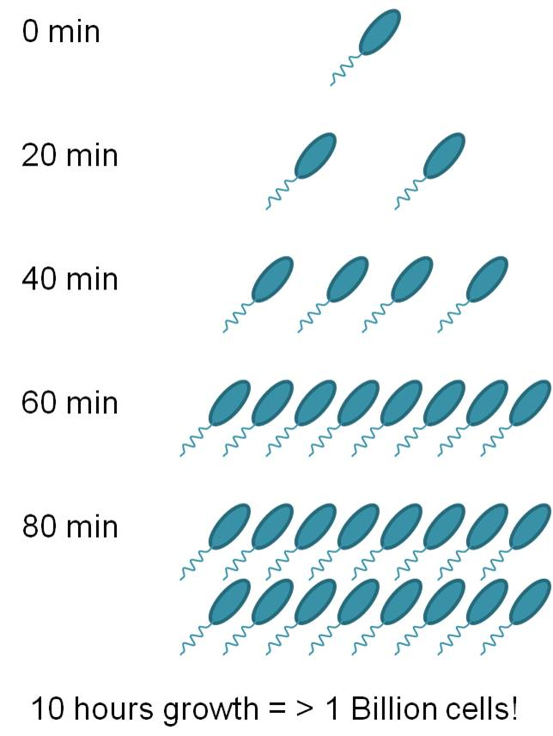

Carrying Capacity
- ________________________________ is the ________________________ population that the ecosystem can support indefinitely.
- While a population may ______________ beyond this number, it will not remain at this increased size.
- Example:
  - Rabbits in Australia demonstrate _________________ growth and _______________________.
  - Originally, there were ________________ rabbits in Australia.
  - When they were introduced in 1859, their numbers grew ______________ because they had plenty of _______________, no ________________, and no _________________.
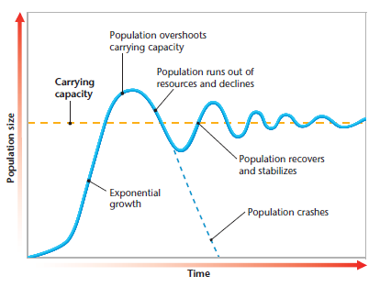
  - Eventually, ______________________ and ________________________ caused the rabbit population to crash. Over time, the vegetation ________________, and the rabbit population began to _________________ again.
  - The increasing and decreasing cycle continues, though less dramatically, as the population stays closer to the carrying capacity over time.

Resource Limits
- A species reaches its _________________________ when it consumes a particular natural resource at the same rate at which the ecosystem ____________________ the resource.
- That natural resource is called a __________________________________________.
- For example, plant growth is limited by supplies of __________________, sunlight, and ______________________.
- The supply of the most ______________________ limited resources determines the current carrying capacity.
Two Types of Population Regulation
1. __________________________________
  - Deaths occur more quickly in a crowded population than in a sparse population.
  - Reasons for deaths-
    - Competition
    - Predation
    - __________________
- _____________________________________
  - When certain portions of the population die regardless of how dense the population is.
  - Reasons for deaths:
    - ___________________
    - Natural disasters
    - Human actions (deforestation, damming a river, hunting, etc.)

