Notes: Environmental Effects on Human Health
- ________________________ causes illnesses directly and indirectly.
- Pollution may cause illness by ________________________ us directly, as in the cases of lead poisoning and lung cancer.
- Second, because many infections diseases, such as ________________________ and river blindness, spread in polluted environments, illness can be caused indirectly.
- The _____________________________________________ (WHO) has begun to collect data on how the environment affects human health.
- In one study, WHO estimates poor health by days of healthy life lost to death and disease in different world regions.
- The study shows that, in general, people in ________________________ countries suffer ________________________ health impacts.
- The main factor is the enormous role of infectious diseases which are more common in crowded areas with poor sanitation.
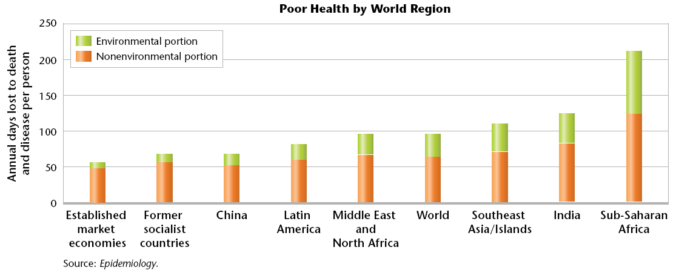
Toxicity: How Dangerous Is It?
- _________________________________________ is the study of toxic substances, including their nature, effects, detection, methods of treatment, and exposure control.
- Several pollutants have toxic, ___________________________, effects.
- The toxic effect of a chemical depends on:
  - Dose
  - ____________________________________
  - ____________________________________
  - Body’s ability to break down the chemicals
Epidemiology
- ___________________________________ is the study of the distribution of diseases in populations and the study of factors that influence the occurrence and spread of disease.
- Scientists trace the disease to try to find its origin and how to prevent it from spreading.
Pollution from Natural Sources
- ____________________________________ occurring pollutants usually become hazardous to health when they are concentrated _________________________ their normal levels in the environment.
- The most common pollutants from natural sources are _________________, soot, and other particulates.
Heavy Metals
- Another pollutant from natural sources are the so-called __________________________.
- Dangerous heavy metals include the elements __________________, cadmium, lead, and __________________________.
- These elements occur naturally in rocks and soil.
- Most of these elements cause __________________________ when they are ingested beyond their threshold dose.
Recent Improvements
- _________________________________ in the United States have helped reduce exposure to pollutants. Most vehicles and factories now have pollution-control devices.
- On average, people contain lower levels of some toxic chemicals in their bodies than in the past.
- Because we know so little about the effects of chemicals on our health, new health risks are discovered frequently.
- For example, scientists now think that chemical pollution may be part of the cause of _____________________________ and ___________________________________ diseases.
Burning Fuels
- ____________________________________is still a major health problem, despite the very real advances in public health resulting from pollution control.
- Burning fuels in vehicles, home furnaces, power plants, and factories introduces enormous amounts of pollutants into the air, including the gas ____________________________________
- These pollutants and particulates contribute to premature death each year from ______________________________, heart disease, and lung disorders.
Waste Disposal
- Much of the pollution in our environment is a byproduct of inadequate _________________________________________.
- Although methods of disposing waste have improved, problems remain.
- Laws regulating waste disposal are not always enforced.
The Environment’s Role in Disease
- Some of the damage to human health is not caused by toxic chemicals but by organisms that carry disease.
- Infectious diseases are caused by _________________________________, a virus, microorganism, or other substance that causes disease.
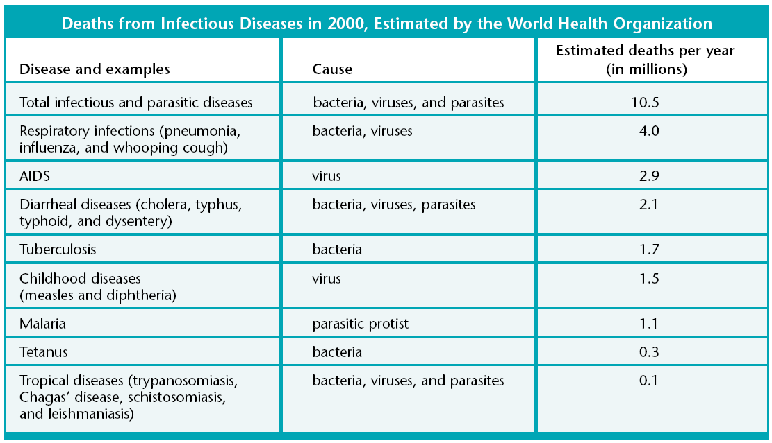
Cholera
- Nearly three-fourths of infectious disease are transmitted through water.
- The deadliest waterborne diseases, such as those that cause __________________________ and ________________________________, come from drinking water polluted by human feces.
- These diseases cause the body to lose water and become dehydrated, and they cause most of the __________________________________________________ around the world
Antibiotic Resistance
- By ____________________________ the environment, we make it more suitable for pathogens to live and reproduce.
- Our actions cause pathogens to evolve ______________________________ to antibiotics that are used to kill them.
- In 1979, 6% of European strains of pneumonia bacteria were resistant to antibiotics. Ten years later, _______________________ of the strains were resistant.
Emerging Viruses
- In recent years, medical scientists have been focusing on previously unknown viruses.
- Examples of these “________________________________” include the hanta virus, the Ebola virus, the West Nile virus, and the _________________, which causes AIDS.
- Most viral diseases spread directly from one person to another.
- Often, the virus invades the body through a cut or through mucus membranes.
- We do not have many effective drugs to treat viral diseases.
- Our main defense against viral diseases is ___________________________________.
- However, vaccines are virus ____________________________ and viruses evolve rapidly.
- New vaccines must be _________________________ when a new strain of a viral pathogen evolves.

