Microscope Notes
- What do you need to know about microscope care and use?
  - ALWAYS carry the microscope with _____________ hands.
  - Only clean the lenses with _____________ paper.
  - NEVER force ____________________ or _______________________.
  - Store ________________________.
  - Start on the ______________________ objective.
  - Focus with ____________________________ knob first.
  - NEVER EVER try to use the ________________________________ lens without teacher direction!!!!!
- How do you calculate the power of magnification?

- Calculate the power of magnification for each objective lens.
Objective Power | Eyepiece Lens Power | Power of Magnification
4
10
40

- What happens to your view of an image as you increase the power of magnification?

- Why can’t you use the largest objective for some slides?

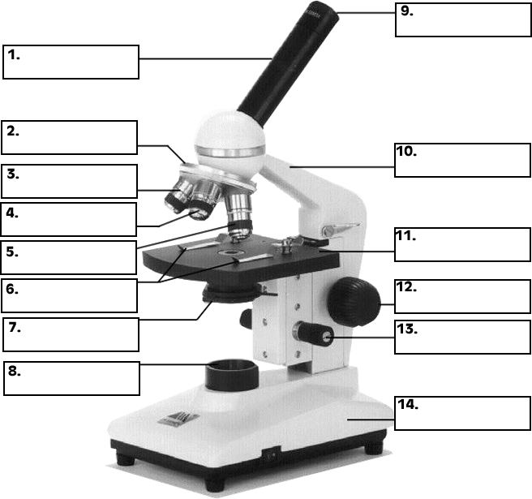
Objective Lens
Same as #3
Same as #3

