Chapter 9 -The Human Population
Studying Human Populations
- ____________________ is the study of the characteristics of populations, especially ________________populations.
  - Demographers study the historical size and makeup of the populations of countries to make comparisons and predictions.
  - Demographers also study properties that affect population growth, such as economics and social structure.
- Countries with _________________ population trends are often grouped into two general categories: developed and developing countries.
- ________________________ countries
  - higher average incomes, slower population growth, diverse industrial economies, & stronger social support systems
- ________________________ countries
  - lower average incomes, simple & agriculture-based economics, & rapid population growth
The Human Population Over Time
- ________________________________ in the 1800s (population growth rates increased during each decade)
- Mostly due to _____________________ death rates
  - increases in food production -safe sewage disposal
  - clean ______________________ -discovery of vaccines
  - improvements in hygiene
However, it is unlikely that the Earth can sustain this growth for much longer.
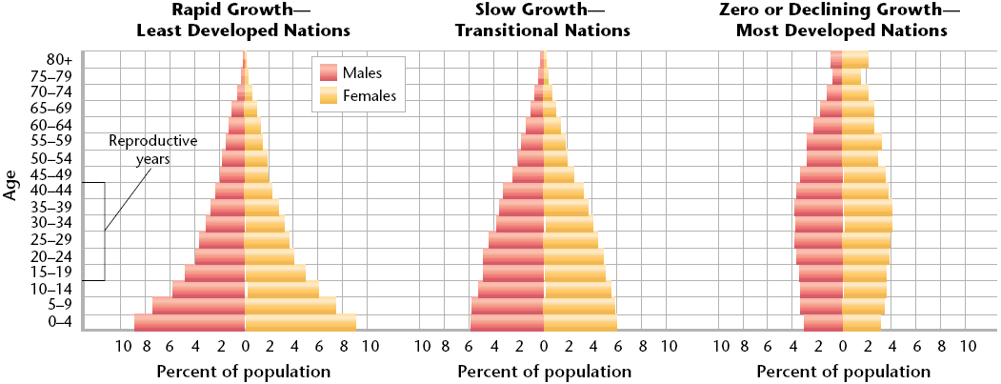
Age Structure
- Classification of members of a population into groups
by age or distribution of members of a population in terms of ________________ groups
- Helps make _________________________
- Countries with high rates of growth usually have more young people. Countries that have slow or no growth usually have an even distribution of ages in the population.
- Graphed in a _________________________pyramid
Survivorship
- ________of newborns in a population that can be expected to survive to a given age
- Used to _____________ population trends
- To predict survivorship, demographers study a group of people born at the same time & notes when each member of the group dies.
Fertility Rate
- The number of __________________ (usually per year) per ___________________women of childbearing age (usually 15 to 44)
- Replacement level is the average number of children each parent must have in order to “replace” themselves. This number is slightly more than 2 because not all children born will survive & reproduce.
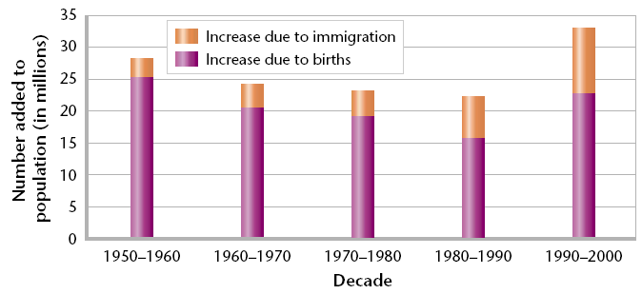
Migration
- Any ______________________ of individuals or populations from one location to another
- Movement INTO an area=Immigration
- Movement OUT of an area=Emigration (Exit)
Life Expectancy
- Average length of time that an individual is expected to _____________________
- Most affected by _________________mortality
- Expensive medical care is not needed to prevent infant deaths. Infant health is more affected by the parents’ access to education, food, fuel, and clean water.
The Demographic Transition
- The general pattern of demographic change from high ___________ & death rates to low ____________& death rates, & observed in the history of more-developed countries
  - Industrial development causes economic & social progress that then affects population growth rates
Changing Population Trends
- Throughout history, populations that have high rates of growth create environmental ___________________.
- A rapidly growing population uses resources at an increased rate & can ________________ the infrastructure of a community.
- ______________________ is the basic facilities of a country or region, such as roads, bridges, sewers, power plants, subways, schools, & hospitals.
Problems of Rapid Growth
- Uses resources __________________ than the environment can renew them
- Standards of living decline when wood is removed from local forests faster that it can grow back, or when ______________overwhelm local ___________________sources.
- Symptoms of overwhelming populations include suburban sprawl, __________________ rivers, barren land, inadequate housing, & overcrowded schools.
Unsafe Water
- In places that lack infrastructure, the local water supply may be used not only for drinking & washing but for ___________________disposal.
- The water supply then becomes a breeding ground for organisms that can cause ______________________.
- Many cities have populations that are doubling every 15 years, & water systems can’t be expanded fast enough to keep up with this _____________________.
Impacts on Land
____________________ is farmland that can be used to grow crops.
- __________________populations make trade-offs between competing uses for land such as agriculture, housing, or natural habitats.
  - For example, Egypt has a population of more than 69 million that depends on farming within the narrow Nile River valley.
  - Most of the country is desert, and less than 4 percent of Egypt’s land is arable.
  - The Nile River Valley is also where the jobs are located, and where most Egyptians live. They build housing on what was once farmland, which reduces Egypt’s available arable land.
A Demographically Diverse World
- Populations are still _______________ rapidly in less developed countries, with most of the world’s population now within Asia.
FACTORS AFFECTING HUMAN POPULATION SIZE
- The world’s 10 most populous countries in 2006 with projections in 2025.
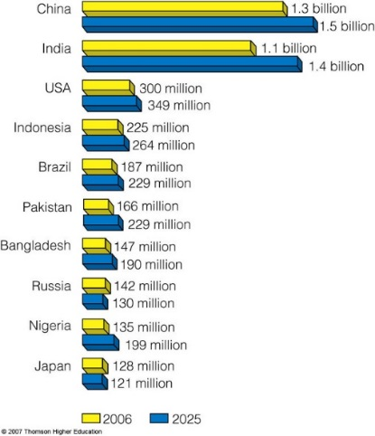
Managing Development & Population Growth
- In 1994, the United Nations held the International Conference on __________________ & Development (ICPD),
- It involved ______________about the relationships between population, development, & the environment.
- Many countries _________________ stabilizing population growth through investments in development, especially through improvements in women’s status.
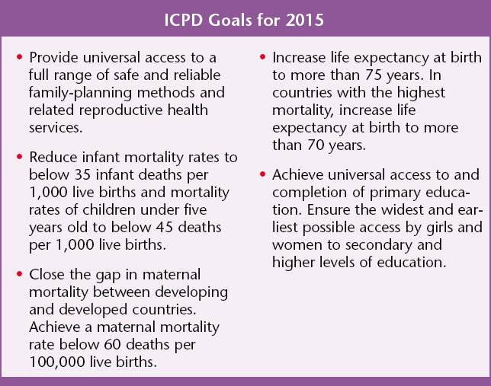
- With these goals, worldwide _______________________ rates are dropping as shown below.
Growth Is Slowing
- ___________________ rates have declined in both more-developed & less-developed regions.
- ___________________________ predict that this trend will continue & that worldwide population growth will be slower this century than the last century.
- If current trends continue, most countries will have ___________________________level fertility rates by 2050. If so, world population growth would eventually stop.
Factors Affecting Birth Rates and Fertility Rates
- The number of children women have is affected by:
  - The ___________of raising and educating them.
  - Availability of pensions.
  - Urbanization.
  - Education and employment opportunities.
  - Infant _________________.
  - Marriage ________________.
  - Availability of contraception and abortion.

SOLUTIONS: INFLUENCING POPULATION SIZE
- The best way to slow population growth is a combination of:
  - Investing in _________________planning.
  - Reducing _____________________.
  - Elevating the ____________________of women.

SLOWING POPULATION GROWTH IN INDIA AND CHINA
- For more than five decades, India has tried to control its population growth with only ______________________success.
- Since 1970, China has used a government-enforced program to cut its birth rate in half and sharply reduce its ________________ rate.
India’s Failed Family Planning Program
- __________________planning.
- Bureaucratic inefficiency.
- _______________status of women.
- Extreme ________________.
- Lack of administrative financial support.

- Disagreement over the best ways to slow population growth.
China’s Family Planning Program
- Currently, China’s TFR is ___________ children per women.
- China has moved 300 million people out of ________________________.
- Problems:
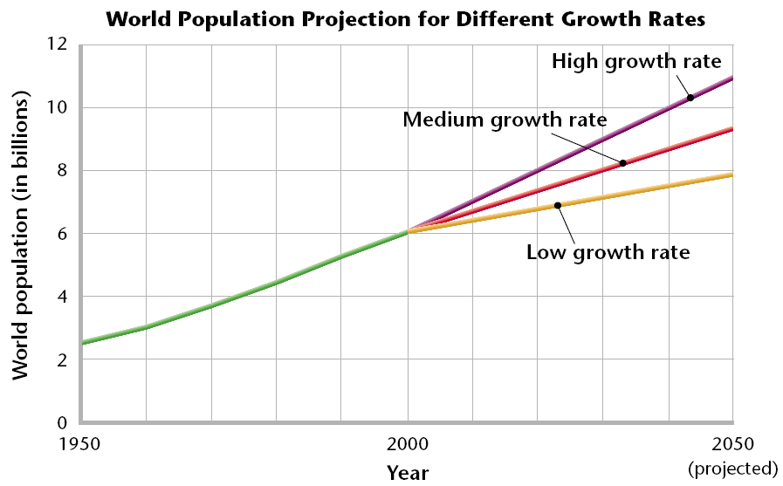
  - Strong ________________ preference leads to gender imbalance.
  - Average population age is increasing.
  - Not enough ______________________ to support population.
Projections to 2050
- Looking at the graph below, most demographers predict the _____________ growth rate, and a world population of 9 billion in 2050.

