Name: ___________________________
Environmental Decisions Chapter 2.3 Notes
Values and the Environment
SCIENTIFIC research is an essential first step in solving environmental problems.
•However, before research can begin, an EXAMINATION of values is usually needed.
VALUES are principles or standards that an individual considers to be important.
•There are many values that affect environmental decision making.
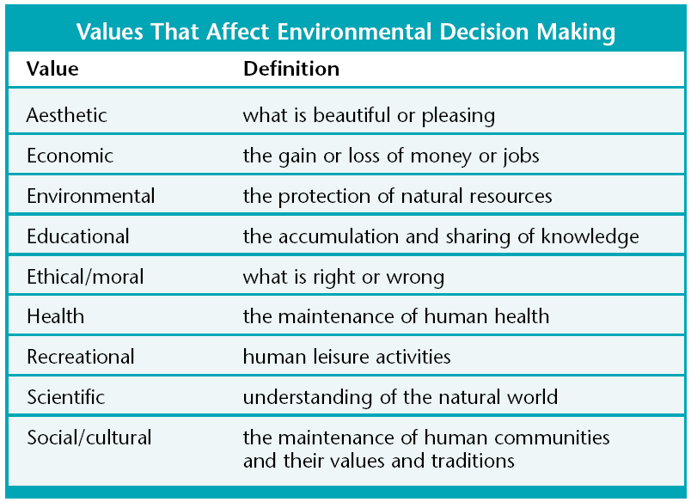
An Environmental Decision-Making Model
•A DECISION-MAKING MODEL is a conceptual model that provides a systematic process for making decisions.
•Decision-making models can be used to help you make decisions about
ENVIRONMENTAL ISSUES which can be very difficult.
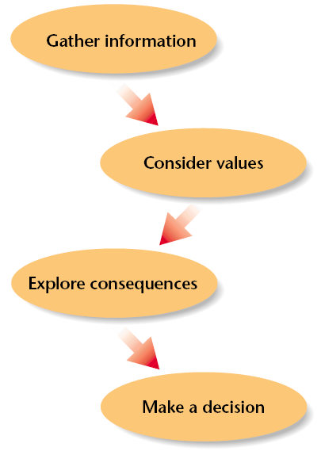

A Decision-Making Model
•The first step in the model is to GATHER INFORMATION This includes things such as watching news reports, and talking to experts.
•Second, consider which VALUES apply to the issue.
•Next, explore the CONSEQUENCES of each option.
•Finally, CONSIDER all of the information and make a decision.
A Hypothetical Situation
•The golden-cheeked warbler population is declining in Valley County.
