Ecological Relationships Notes

Predation
- An organism that feeds on another organism is called a ________________________________.
- The organism that is fed upon is the ____________________.
- Examples:
  - Snakes eating _________________.
  - ____________ eating insects.
  - Whales consuming ____________________.
- Some predators eat only _______________ types of prey.
- In this type of relationship, the ______________ of each population tend to __________________ and __________________ in linked patterns.
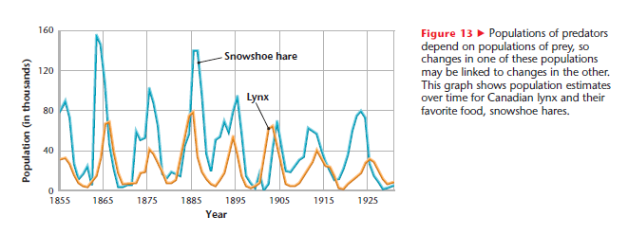

Competition
- Competition is a relationship in which ___________________ individuals or populations attempt to use the _________________ limited resource.
- Each individual has _________________ access to the resource and so is _________________ by the competition.
- Competition can occur both _________________ and ____________________ species.
- Indirect competition occurs when species _________________ come in contact with each other.
  - Examples:
    - If one species _____________ on a certain plant during the day and another species feeds on the ______________ plant at night.
    - ________________ rarely interact with the insects that eat our _____________, but the insects are still competing with us for food.

Symbiosis
- The close association between two or more organisms of _____________________ species
- Three types of symbiosis:
  - ___________________________
  - Commensalism
  - ___________________________

Mutualism

- A ________________________ relationship between two organisms of different species in which each member ________________.
- Examples:
  - ___________________perched on a black rhinoceros get food (pests on rhinos) and help the rhino get rid of pests
  - One kind of _________________________ lives in the guts of termites and digests the cellulose in the wood that the termites eat. ________________________ the protozoa, the termites could not completely digest the cellulose.
  - Some types of _______________________ grow on the roots of plants and release an acid that changes minerals in the soil into forms that plants can _____________________.
  - You and a species of _______________________ that lives in your intestines benefit each other! The bacteria get a plentiful food supply from you and in return you get __________________that the bacteria produce.
  - The living corals near the surface of the water provide a home for ____________________. The algae produce food through ______________________________ that is used by the corals.

Commensalism
- A symbiotic relationship between two organisms of different species in which one organism ________________ without ___________________ the other organism
- Examples:
  - _______________________attached to a gray whale gain a home and ___________________ to areas with food while leaving the whale unaffected.
  - Remoras hitch a ride and feed on scraps of food left by sharks. The remoras ______________ from this relationship while sharks are _____________________________.
  - The Cattle _______________(Bubulcus ibis) is often found in pastures following horses and cattle. As the livestock graze, insects are stirred up by their movement and this provides _____________________for the egrets.
  - The Great Burdock (Arctium lappa) has spines on its seeds that curve upward which allow the seeds to attach themselves to the _________________ of passing animals. The plant _______________________________by having its seeds dispersed in a large area and the animals are not affected.
  - _____________________ receive more sunlight for __________________________________ if they grow high on tree branches. The orchid plants are helped by the tree. The tree gets nothing in return from the orchids.

Parasitism
- A symbiotic relationship between two organisms of different species in which one organism _________________________ and the other is ______________________.
  - The organism that benefits is called the _____________________________.
  - The organism that is harmed is called the _______________________.
- The parasite gets nourishment from its host, which is weakened in the process. Sometimes a host organism becomes so weak that it dies.
- Some parasites, such as ticks, live __________________________________the host’s body.
- Other parasites, such as tapeworms, live ____________________________ the host’s body.
- Examples of Parasitism
  - The ________________________ parasite, Giardia Lamblia, lives in the digestive tracts of humans and other vertebrates causing _______________________________ and severe stomach cramps. Giardia lives in water and sometimes hikers drink infected water.
  - A ____________________ on a human scalp receives _____________________________ by drinking the human’s blood, and also causes a rash or irritation.
  - A female _________________________ lays _________________________ in a caterpillar. When the eggs hatch, the wasps eat the caterpillar alive!
  - A _________________ uses the ______________________ of the rabbit for nourishment.
  - Lampreys attach to fish causing sores.

