Cycles through the Ecosystem

Water Cycle
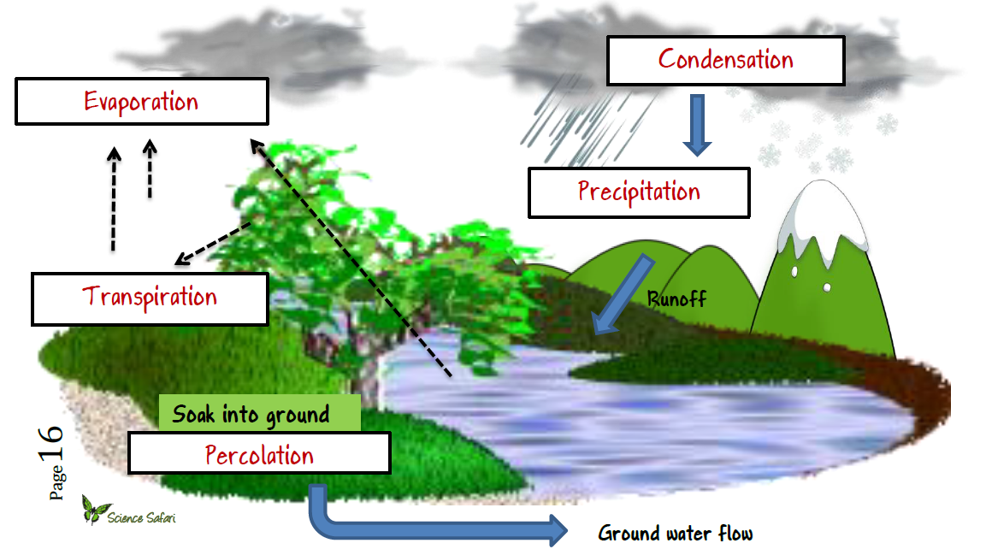
The water cycle is also called the hydrologic cycle. Condensation is the process that turns water vapor into liquid, which causes the formation of a cloud. After it rains, the water can either end up on land or in a body of water, such as streams, lakes, and oceans. When water evaporates from a leaf, this process is called transpiration. When water is heated in an ocean, the liquid water changes form and turns into water vapor. When water leaves a body of water after it is heated, the process is called evaporation. When water falls from the sky, the process is known as precipitation. When water hits land and is soaked into the ground, the water becomes ground water. The water cycle is a continual process, water passes from atmosphere to the Earth and back to the atmosphere.

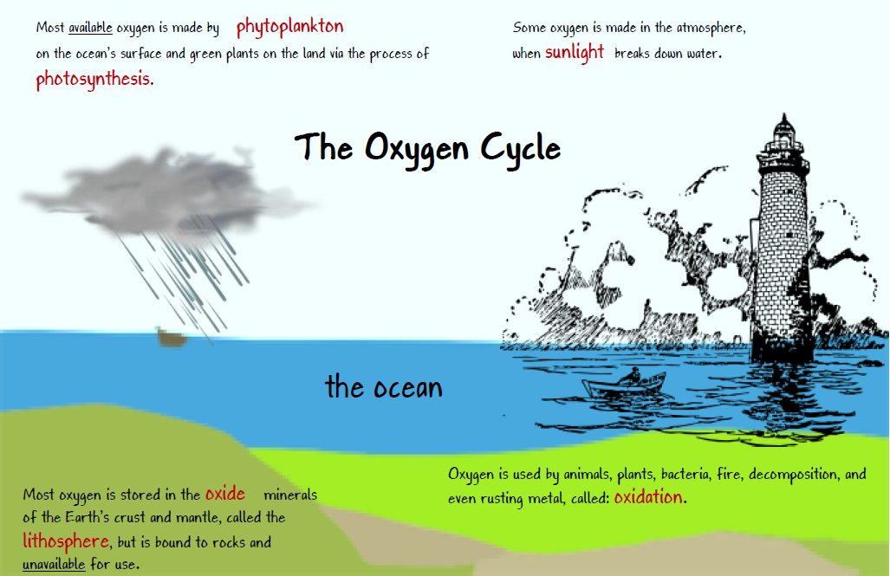
Oxygen Cycle
Plants release 430-470 billion tons of oxygen during the process of photosynthesis. Atmospheric oxygen in the form of ozone provides protection from harmful ultraviolet rays. Oxygen is found everywhere on Earth, from Earth’s crust (rocks) to the ocean where it is dissolved. Oxygen is vital for respiration by animals, a process which produces CO₂ and water. Oxygen is also necessary for the decomposition of waste into other elements necessary for life.
The equation for cellular respiration is C₆H₁₂O₆ + 6O₂ 6CO₂ + 6H₂O + energy.

Carbon Cycle
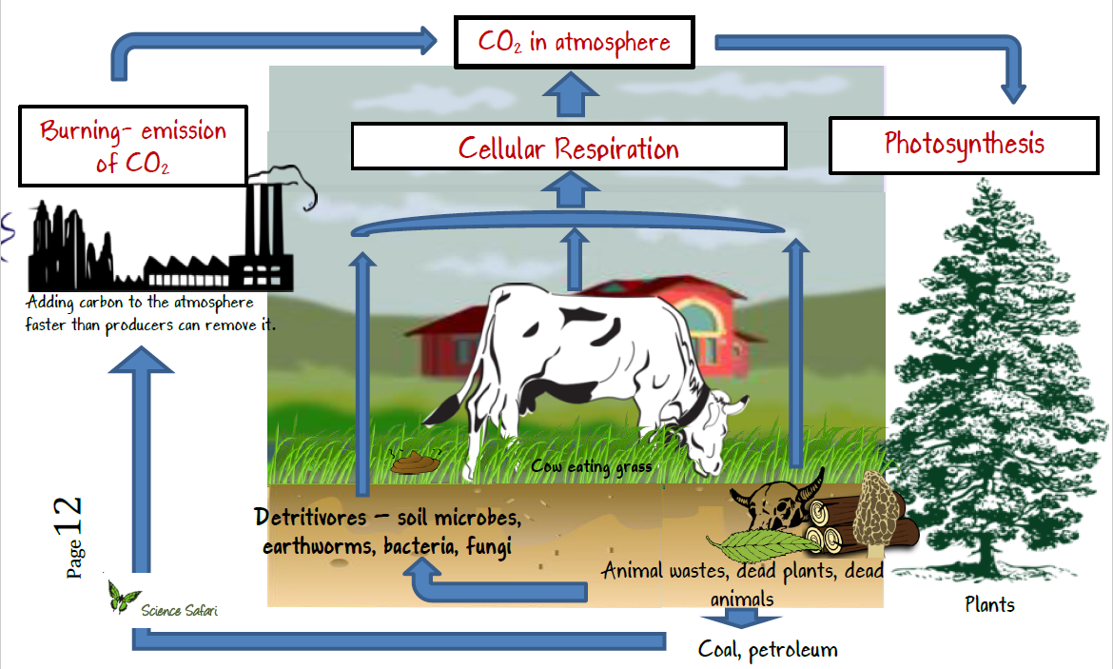
Plants use CO₂ in the process of photosynthesis to make sugar and oxygen. Animals use oxygen in the process of respiration and make more CO₂. The ocean is the main regulator of CO₂ in the atmosphere because CO₂ dissolves easily in it. In the past, huge deposits of carbon were stored as dead plants and animals decayed. Today these deposits are burned as fossil fuels, which include oil, natural gas, and coal. More CO₂ is released in the atmosphere today than in the past because of the burning of fossil fuels. Another natural source for CO₂ is methane. Too much CO₂ in the atmosphere may be responsible for the greenhouse effect.
The equation for photosynthesis is 6CO₂ + 6H₂O+ light C₆H₁₂O₆ + 6O₂.

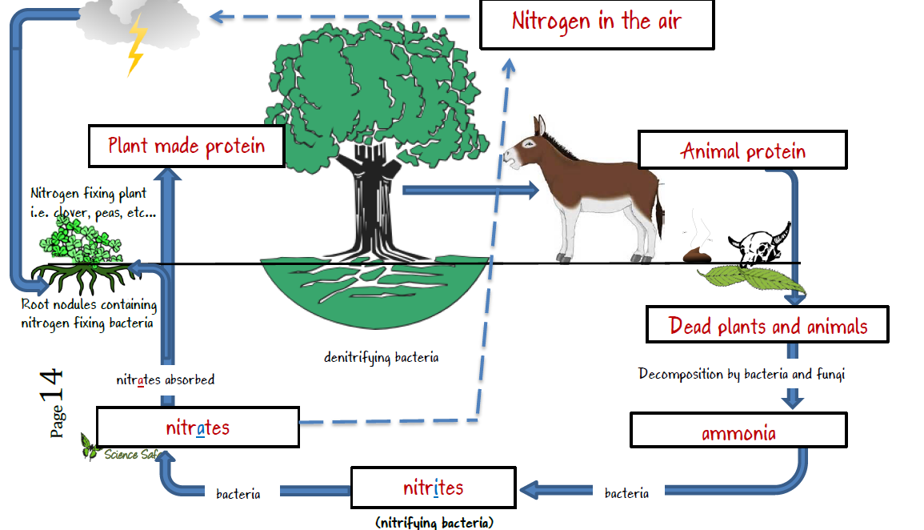
Nitrogen Cycle
Our atmosphere is 78% nitrogen gas. Animals and plants cannot directly use all the nitrogen found in our atmosphere. Only special bacteria can directly use nitrogen in our atmosphere and “fix” it so other organisms can benefit. These bacteria are called nitrogen-fixing bacteria.
Higher organisms use nitrogen to make their proteins. Animal waste decay by the action of bacteria which create ammonia and nitrate products rich in nitrogen, and useful for plants to use again. Denitrifying bacteria in the soil can break down the ammonia into the gaseous form of nitrogen, which is not available for use by plants or animals. In another part of the cycle, animals eat plants containing nitrogen, which is again returned to the soil by animal waste or decaying plants and animals.

Phosphorus Cycle
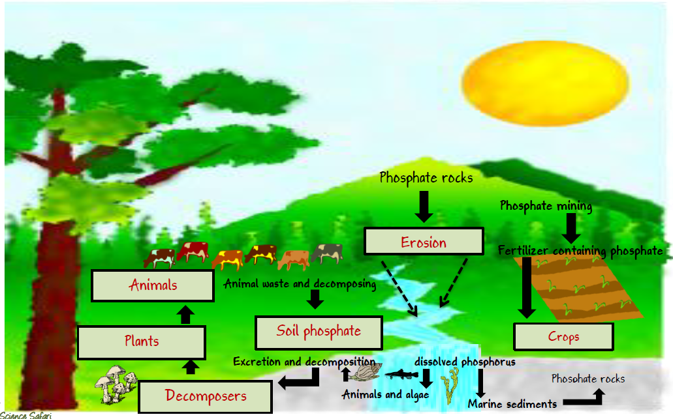
Phosphorus is NOT found in the free state in nature, but is contained mostly in rocks and minerals. It is an essential nutrient for life, as it makes up important chemicals such as DNA. In the phosphorus cycle, phosphorus moves between the soil and plants, which are eaten by animals. The animals use phosphorus, and then their waste products help return the sulfur for the next generation of phosphorus in the soil. Some of the phosphorus in soils can be washed away into water pollution. Another source of phosphorus in water comes from man-made basins. Too much phosphorus in water leads to plant overgrowth, strangling all other life forms in the water. The use of too many phosphorus-rich fertilizers is bad for the environment because agriculture runoff goes into aquatic ecosystems which cause plants to grow and overpopulate the water. (Eutrophication)

