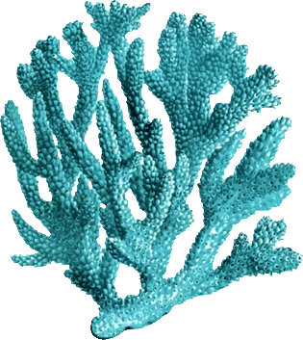
Coral Reef Project (Part 2)
3d Model Creation
For Part 2 of our research project, you will be using the information you gathered from your research paper to creation a 3D representation of your species. There will be several components to this project, with the largest being the model you turn in. All of the models for the Environmental Science classes will be placed on display as a coral reef art installation. The final product will be due Oct 31.
Step 1:
- Use information from your paper to determine the size of your model.
  - Our models will be ½ scale models (Take the size of your organism and divide it by two)
- Create a sketched plan of your model
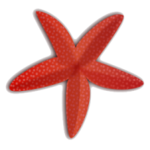
  - We will be creating models in the round, this means they can be looked at from all sides
  - Your sketches need to show at least two sides of your model (Ex. The side and the front)
  - On the page with your sketches, you need to start generating a list of possible materials you can use. Find at least three different materials you could build your model out of
    - Next to each of the materials you list, write a reason this material would work well for your organism
Step 1 Due Date: Oct 19
Step 2:
- You must create your model out of whatever material you decided on from step 1
  - Keep in mind the scale you calculated for step 1!
  - Also, consider that your model will have to be mounted to our display in some way. If you have a coral or an invertebrate, think about a way to secure your organism to the bottom. If you have a fish, think of a way to anchor it so it still looks like it is free swimming.
- Along with your model, you need to turn in an Artist’s Statement. This will allow you to reflect on what you created and how it could be improved if you were to do the project again and is an important part of the artistic process. You will receive a framework for this after the first deadline.
Step 2 Due Date: Oct 31

Wheeler Environmental Science
Coral Reef Project Part 2

______/20 Detailed sketches with list of materials
______/10 Math ½ Scale – Size is ½ the size of the real researched organism
______/20 Artist Statement – Reflection and self-evaluation
______/20 Craftsmanship – Is the artwork neatly executed with effort?
______/20 Completed Model – Is it representative of the researched organism?
______/10 Creativity - Did the project show a meaningful way to depict the organism?

_______/100 Final Grade

