Unit 1- Environmental Decisions Chapter 2.3 Notes
Values and the Environment
• ______________________ research is an essential first step in solving environmental problems.
• However, before research can begin, an _____________________ of values is usually needed.
• ____________________ are principles or standards that an individual considers to be important.
• There are many values that affect environmental decision making.
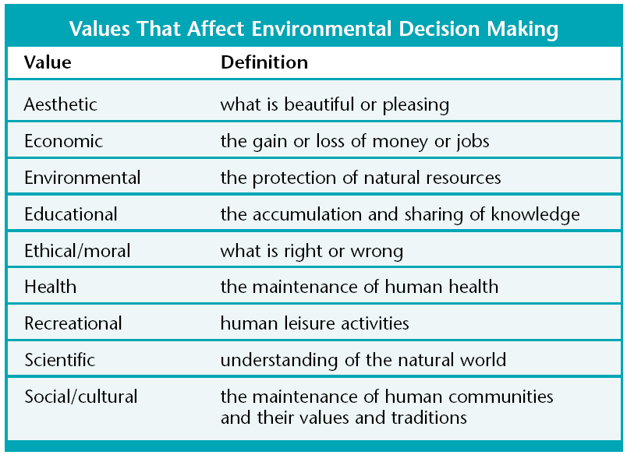
An Environmental Decision-Making Model
• A ______________________________________________ is a conceptual model that provides a systematic process for making decisions.
• Decision-making models can be used to help you make decisions about
_____________________________________________________, which can be very difficult.
Explore Consequences
Gather Information

Consider Values
Make a Decision

• The first step in the model is to _______________________________________. This includes things such as watching news reports, and talking to experts.
• Second, consider which __________________________________ apply to the issue.
• Next, explore the __________________________________ of each option.
• Finally, __________________________________ all of the information and make a decision.
A Hypothetical Situation
• The golden-cheeked warbler population is declining in Valley County.
