Unit 1- Environmental Decisions Chapter 2.3 Notes
Values and the Environment
• ______________________ research is an essential first step in solving environmental problems.
• However, before research can begin, an _____________________ of values is usually needed.
• ____________________ are principles or standards that an individual considers to be important.
• There are many values that affect environmental decision making.
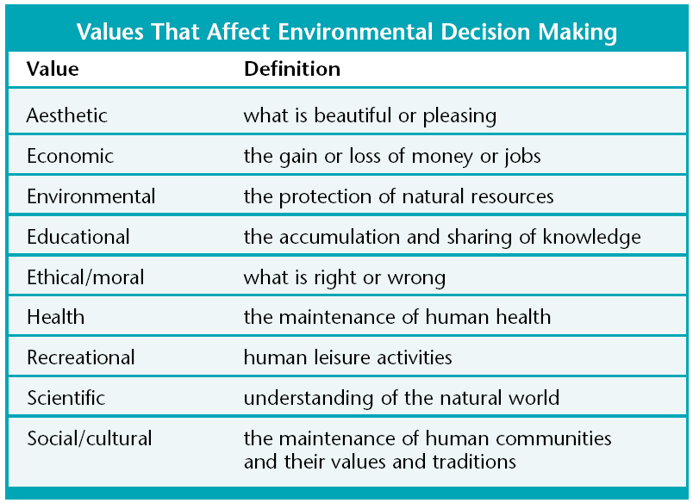
An Environmental Decision-Making Model
• A ______________________________________________ is a conceptual model that provides a systematic process for making decisions.
• Decision-making models can be used to help you make decisions about
_____________________________________________________, which can be very difficult.
Explore Consequences
Gather Information

Consider Values
Make a Decision

• The first step in the model is to _______________________________________. This includes things such as watching news reports, and talking to experts.
• Second, consider which __________________________________ apply to the issue.
• Next, explore the __________________________________ of each option.
• Finally, __________________________________ all of the information and make a decision.

Make a Fracking Decision
 | Environmental | Economic | Recreational
Positive short-term consequences
Negative short-term consequences

Positive long-term consequences

Negative long-term consequences

Is fracking worth it? Explain your answer based on the long-term/short-term consequences.

