Environmental Science Notes- Unit 1 Chapter 1.2
“The Tragedy of the Commons”
•In his essay, ecologist Garrett Hardin argued that the main difficulty in solving environmental problems is the __________________________ between the short-term interests of the individual and the long-term welfare of society.
•The solution may be to override the short-term interests of the individual and improve the _______________________________ for everyone in the long run.
Supply and Demand
•The Law of Supply and Demand is a law of economics that states as the ________________________________ for a good or service increases, the cost for the food or service also increases.
•An example is the world _____________________production.
Costs and Benefits
•The cost of environmental solutions can be high.
•A cost-benefit analysis balances the ________________________of the action against the ________________________ one expects from it.
•The results depend on who is doing the analysis. For example, pollution control may be too costly to an industry, but to a nearby ___________________________________, the price may well be worth it.
Developed and Developing Countries
•The _____________________________ distribution of wealth and resources around the world influence the environmental problems and solutions a society can make.
•Developed countries have _________________________ incomes, slower population growth, diverse industrial economies, and stronger social support.
•Developing countries have ____________________________average incomes, simple agriculture-based communities, and rapid population growth.
Local Population Pressures
•When the population in an area grows _______________________________, there may not be enough natural resources for everyone to live a healthy, productive life.
•In severely overpopulated regions, forests are stripped bare, topsoil is _______________________________, and animals are driven to extinction.
•In these areas, malnutrition, ______________________, and disease can be constant threats.
Consumption Trends
•To support the higher quality of life, developed countries are using much more of Earth’s resources.
•Developed nations use about 75 percent of the world’s resources, although they make up only 20 percent of the world’s population.
•This rate of consumption creates more waste and pollution per person then in developing countries.
Ecological Footprints
•An ecological footprint is one way to express the _____________________________ in consumption between nations.
•Ecological footprints are calculations that show the productive area of Earth needed to _________________________ one person in a particular country.

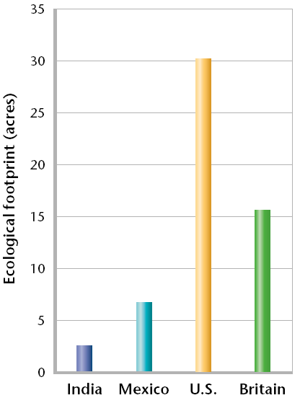
A Sustainable World
•Sustainability is the condition in which human needs are met in such a way that a human population can _________________________ indefinitely.
•Sustainability is a key goal of environmental science.
•Our current world is not ____________________________ as the developed countries are using resources faster than they can be replaced.
•Achieving a sustainable world requires ______________________________ participation including individual citizens, industry, and the government.

