Chapter 10- Biodiversity
- Short for “__________________________”
- Number and variety of ________________ species in an area
- 1.7 million known species, most insects
- Estimated over 10 million
Levels of Diversity
- Species diversity- All the differences between the populations of a species, _______________ species
- Ecosystem diversity- Variety of ______________, communities, and ecological processes within and between ecosystems
- Genetic diversity- Different _________________ contained within all members of a population (Gene pool)
Benefits of Biodiversity
- Species ___________ within food web
- Keystone species- Species ___________ to the functioning of the ecosystem
  - Ex: _______________ and kelp beds
  - Sea Otters protected…eat sea urchins…kelp beds regenerated.
- Larger populations with larger gene pools survive under pressure
- Bottleneck- As populations shrink, the gene pool does as well
  - Increase in genetic disorders
- Some species used for food, clothing, shelter, and ________________
- ¼ of drugs derived from plants
- Almost all ___________ from fungi
- ____________________ or studied species represent potential products
- Most ___________ originated from a few areas of __________ biodiversity
- Hybrid- New crop variety from genetic __________________
- __________________ can result from dependence on too few plants
Ethics, Aesthetics, and Recreation
- Species and ecosystems have the right to __________________ regardless of value
- Some cultures believe _________________ has a higher purpose
- Outdoor activities enhanced by nature
- _____________________________- Supports the conservation and sustainable development of ecologically unique areas
Current Extinctions
- ________________________________- many species extinct in a short time
  - Dinosaurs, 65 million years ago
  - 25% of all species by 2100
- Species prone to extinction
  - Not cockroaches and rats
  - __________________________ populations
  - Migrating species
  - Those with large or special habitats
  - ____________________________________________

- _____________________________- Likely to become extinct
- __________________________- Declining population and in danger of becoming endangered

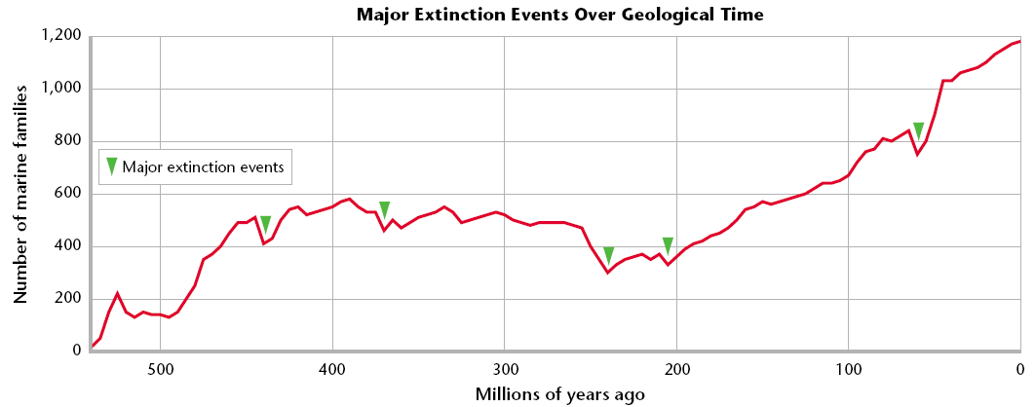
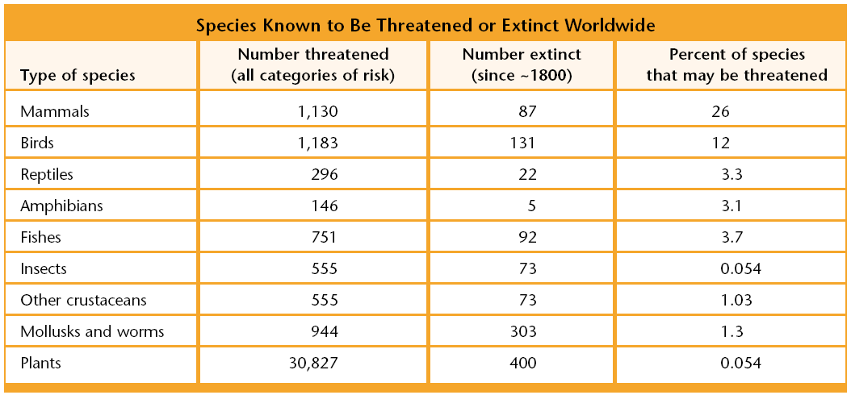
How Do Humans Cause Extinctions?
- _________________ and fragmentation
  - 75% of extinctions
  - Ex: Florida panther
- _________________ exotic species (non-native)-Not native to region
- Harvesting, hunting, and ______________
  - Passenger pigeons (early 1900s)
  - American bison
- _________________
  - DDT and Bald Eagle
Areas of Critical Biodiversity
- ______________________________- Native to/found only in certain region
- Tropical Rain Forest
  - A/B 7% of Earth’s surface
  - ____________ of the world’s species
- ______________________________ and Coastal Ecosystems
  - Fraction of marine environment with many species
  - 60% threatened by humans
- Islands
  - Distinct but limited species
  - Ex: Hawaii and Honeycreepers
- _________________________________- Most threatened areas of high species diversity
- Biodiversity in the ________________
  - CA Floristic Province: 3, 488 native plants; 2,124 endemic sp; and 565 threatened/endangered
  - Everglades, CA coast, Hawaii, Midwest prairies, Pacific NW forests
Biodiversity Hotspots
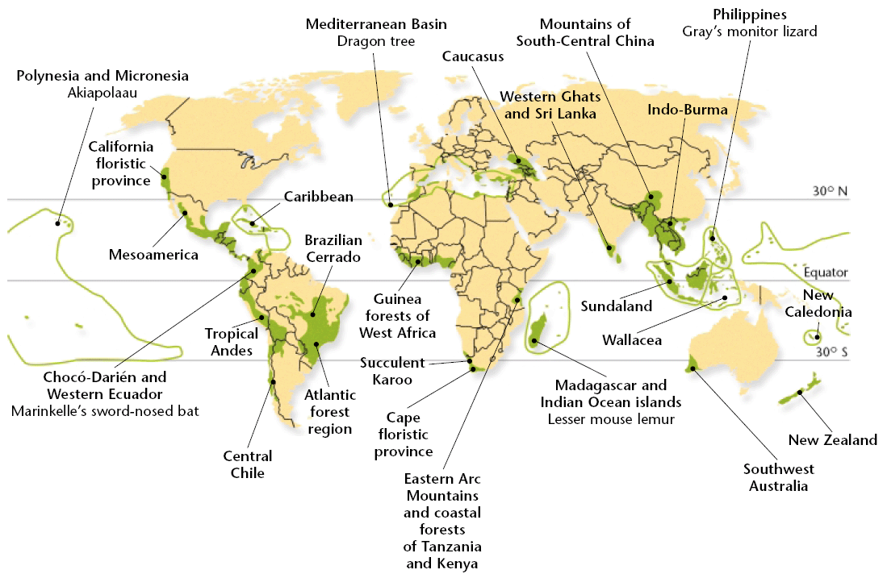
Saving Species One at a Time
- __________________ to return to wild.
  - Ex: CA Condor
  - 9 left in 1986
  - 58 in wild/102 in captivity (2002)
- __________________ Genetic Material
  - Germ plasm banks (reproductive cells)
- _______________, Aquariums, and Gardens
  - Some species last hope
  - Living museums
- More Study Needed
  - Captive species may not reproduce or survive in wild
  - Small pop. vulnerable to infectious disease and inbreeding
Preserving Habitats and Ecosystems
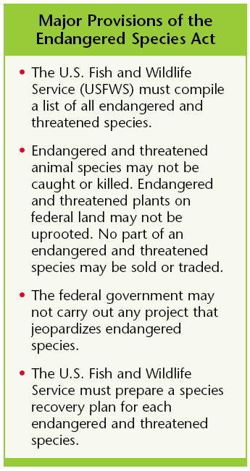
- Most effective way to save species-_________________________________
- ___________________________ strategies
  - Protect entire ecosystems
  - Focus on ___________________________
- More Study Needed
  - Research species and ecosystems
Legal Protection for Species
- _________________
  - 1973-Endangered Species Act
  - USFWS- list of endangered and threatened species; 983 in 2002
- USFWS must prepare a _________________________________________
  - Propose to restore or protect habitat
  - Controversy between developers and conservationists
- ___________________________________
  - Protect one or more species across large areas of land through trade-offs or cooperative agreements
International Cooperation
- International Union for the ________________________of Nature and Natural Resources (IUCN)
  - Over 200 gov’t. agencies and 700 private organizations
- International Trade and _______________________
  - Convention on International Trade of Endangered Species (CITES)
    - Stopped slaughtering of African elephants
- _____________________
  - To preserve biodiversity and and ensure sustainable and fair use of genetic resources
  - United Nations Conference on Environment and Development (Earth Summit) in 1992.
- Private Conservation Efforts
  - More effective
  - World Wildlife Fund; The Nature Conservancy; Greenpeace International
Balancing Human Needs
- Protecting species often ________________
- Some endangered species sources of ______________________ or income
- Not considered _____________________ due to a lack of understanding
- Understanding is key to ________________ species

