Name: ___________________________________
Environmental Science Notes – Unit 1 Chapter 1.1
What Is Environmental Science?
•Environmental Science is the study of the ___________________, water, and land surrounding an organism or a community, which ranges from a small area to Earth’s entire biosphere.
•It includes the study of the impact of _______________________ on the environment.
The Goals of Environmental Science
•A major goal of environmental science is to understand and ____________________ environmental problems.
•To accomplish this goal, environmental scientists study two main types of interactions between humans and their environment:
1)How our actions alter our __________________________________.
2)The use of natural __________________________________.
Many Fields of Study
•Environmental science is an _______________________________science, which means that it involves many fields of study.
•Important to the foundation of environmental science is ecology.
•__________________________________ is they study of interactions of living organisms with one another and with their environment.
Hunter-Gatherers
•Hunter-gatherers are people who obtain food by collecting plants and by hunting wild animals or scavenging their remains.
•____________________________________affect their environment in many ways:
1)Native American tribes hunted buffalo.
2)The tribes also set fires to burn prairies and prevent the grow of trees. This left the prairie as an open grassland ideal for hunting bison.
Hunter-Gatherers
•In North America, a combination of rapid climate changes and _________________________ by hunter-gatherers may have led to the ___________________________ of some large mammal species, including:
1)giant sloths 2)giant bison 3)mastodons 4)cave bears 5)saber-toothed cats

The Agricultural Revolution
•________________________________ is the raising of crops and livestock for food or for other products that are useful to humans.
•The agricultural revolution allowed human populations to grow at an unprecedented rate.
•As populations grew, they began to concentrate in smaller areas placing increased ______________________on the local environments.
The Agricultural Revolution
•The slash-and-burn technique was one of the earliest ways that land was _________________ to farmland.
•Much of this converted land was _________________________armed and is no longer fertile.
The Industrial Revolution
•The ________________________________________________ involved a shift from energy sources such as animals and running water to fossil fuels such as coal and oil.
•This increased use of ______________________________________________changed society and greatly increased the efficiency of agriculture, industry, and transportation.
•For example, motorized vehicles allowed food to be transported cheaply across greater distances.
Improving the Quality of Life
•However, the Industrial Revolution also introduced many new environmental problems such as __________________________________ and habitat loss.
•In the 1900s, modern societies began to use artificial substances in place of raw animals and plant products.
•As a result, we know have materials such as _______________________, artificial pesticides, and _____________________________.
Spaceship Earth
•Earth can be compared to a ______________________________________traveling through space as it cannot dispose of its waste or take on new supplies.
•Earth is essentially a _________________________system.
•This means that the only thing that enters the Earth’s atmosphere in large amounts is energy from the sun, and the only thing that leaves in large amounts is heat.

Spaceship Earth
•This type of closed system has some potential problems.
•Some resources are ______________________________ and as the population grows the resources will be used more rapidly.
•There is also the possibility that we will produce ______________________________more quickly than we can dispose of them.
Population Growth
•The Industrial Revolution, modern medicine, and sanitation all allowed the human ________________________ to grow faster than it ever had before.
Population Growth
•Most scientists think that the human population will almost __________________________ in the 21st century before it begins to stabilize.
•Because of these predictions, we can expect the pressure on the environment will continue to __________________________________ and the human population and its need for food and resources grow.
What are our Main Environmental Problems?
•Environmental problems can generally be grouped into three categories:
1) Resource ________________________
2) Pollution
3) Loss of ____________________________
Resource Depletion
•______________________________________________ are any natural materials that are used by humans, such as, water, petroleum, minerals, forests, and animals.
•Natural resources are classified as either a renewable resources or a _____________________ resource.
Resource Depletion
•__________________________resources can be replaced relatively quickly by natural process.
•__________________________ resources form at a much slower rate than they are consumed.
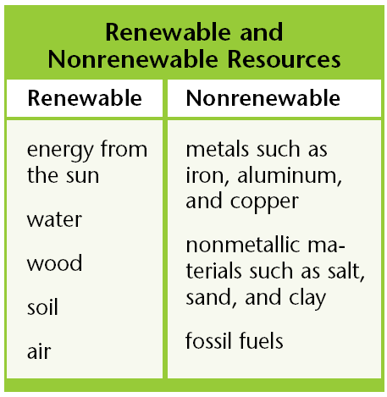
Pollution
•_____________________________________ is an undesirable change in the natural environment that is caused by the introduction of substances that are harmful to living organisms or by excessive wastes, heat, noise, or radiation
•Much of the pollution that troubles us today is produced by human activities and the _______________________________________of wastes.
Pollution
•There are two main types of ___________________________________:
•Biodegradable pollutants, which can be broken down by natural processes and include materials such as newspaper.
•_________________________________________ pollutants, which cannot be broken down by natural processes and include materials such as mercury.
Loss of Biodiversity
•_____________________________________ is the variety of organisms in a given area, the genetic variation within a population, the variety of species in a community, or the variety of communities in an ecosystem.
•The organisms that share the world with us can be considered natural ________________________________.
•We depend on them for food, the _______________________________ we breathe, and for many other things.
Loss of Biodiversity
•Yet, only a fraction of all the species that once roamed the Earth are alive today, and many are ____________________________________.
•Scientists think that if the current extinction rates continue, it may cause problems for the ____________________________________ population.

