Names ______________________________________
Assigned Biome______________________________
Biome Survival Project
Incident Report: You and your group members were the only survivors of a small plane crash approximately 150 miles from the nearest town. The plane is completely wrecked, but you found the following items around the crash site:

- Compass
- 7 Newspapers
- A small amount of steel wool
- Hatchet
- Pistol with 10 bullets
- 1 plastic gallon container filled with drinking water
- 1 can of vegetable oil
- 6 chocolate bars
- 20ft x 20ft tarp
- 4 shirts and 4 pairs of pants
- 1 lighter
- 1 quart of rubbing alcohol
- Small metal pot

Your Objective: Your group must survive in your biome for 3 months (when you will miraculously rescued). Research your biome and prepare a survival plan for your group. Fill in the sections of this survival report. Be thorough and follow directions fully for full credit on this assignment.
Biome Name, General Location(s), and Description:

Crash Location: Include specific latitude & longitude as well as the location marked on the appropriate map.

Dates of Survival: Choose a specific 3 month period. Be sure to check climate information before making your decision.

Climate Information: Include the average annual and monthly temperatures, average annual and monthly precipitation, and any other relevant climate information. Create a climatogram on the appropriate page.

Abiotic Factors and Trends: Discuss the weather patterns, soil, landscape, etc.

Natural Resources: Where is water located? How will you ensure that the water is safe to drink? What sources of renewable energy are available? YOU CAN NOT CUT DOWN LIVING TREES!

Native Flora: What plants are native to this area? Make sure to list plants that may be useful! (i.e., food, medicine, etc…) Are there any potentially hazardous plants? You can include fungi as well.

Native Fauna: What animals are native to this area? Make sure to list animals that may be potential food sources. Are any animals endangered? Are any animals potential predators?

Adaptations: Choose 4 native plants and 4 native animals. Explain how each is adapted to survive in their environment.

Challenges: What sorts of threats are found here? Is this area prone to any natural disasters? Will the weather pose a challenge?

Human Impact: How have humans impacted this area? What are the invasive species in this area?

Chosen Items: Choose 7 items from the list on the front page to bring with you. Provide an explanation for EACH of them.

Food: What will you eat? How will you hunt/capture/gather your food? Create a food web containing you and at least 10 other organisms on the appropriate page.

Shelter: What are your plans for shelter? You may only use the items with you and what you can find in your biome. Make sure that it is biome-appropriate! Remember… you will be there for 3 months!

Labor/Tasks: How will your group divide up the necessary tasks for survival? Think about building, cleaning, cooking, gathering, etc.

YOUR Impact: How can you limit your impact on the environment? Aim to leave the area as you found it.

A Day in the Life…: Outline what one day in your survival would look like. Be specific! Create a map of your camp on the appropriate page.

Biome Location Map

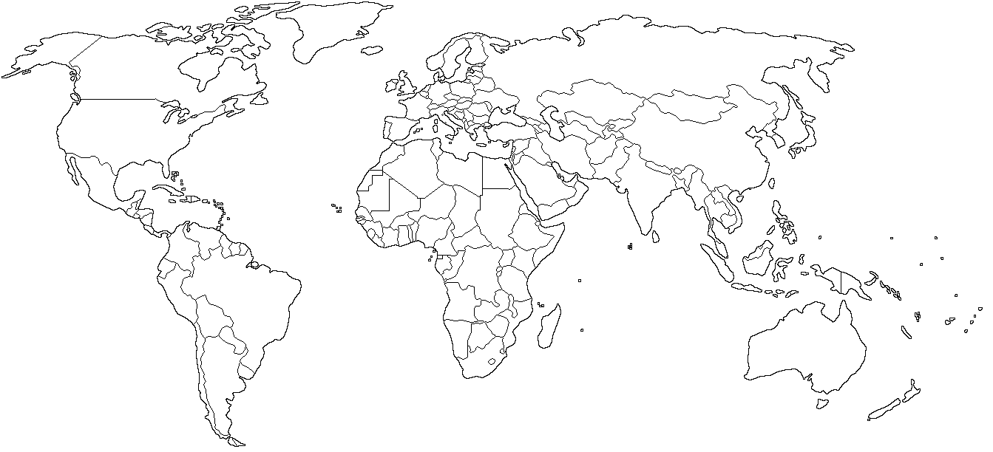

Lightly shade the ENTIRE area of your biome. Clearly label the area you chose for your survival challenge.

Climate Information

Food Web
Include yourself and at least 10 other organisms.

Camp Map
Draw a map representing your camp and the locations of frequently used resources (i.e., food, water, etc.)

Extra Page

