Fantastic Flight
by Tom Brown, Cobb County Science Supervisor

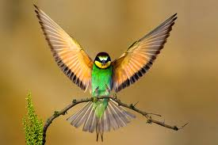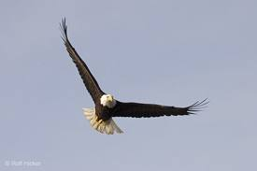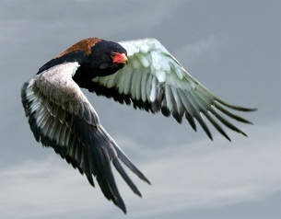

Birds are able to fly because of a variety of specialized adaptations. These adaptations have been designed through the process of natural selection to provide birds with advantages to promote their health and survival. One key adaptation that most birds share is the ability to burn energy quickly (high metabolism). The energy is burned quickly during flight when birds exert strong forces to flap their wings. For example, no animal on earth has a higher metabolic rate than the hummingbird that eats 1 to 3 times their body weight in food per day and burns energy at a rate of roughly 100 times that of an elephant. No such thing as a fat hummingbird.

In addition to a unique ability to burn energy, the feathers of birds are highly adapted to promote flight. They have a variety of different feathers - some of which are "flight feathers" that are long, strong, and are adapted to produce lift and act as control surfaces. The mechanics of flight for a bird are similar to that of an airplane where the factors of lift, weight, thrust, and drag all interact to allow for controlled flight. By flapping their wings, birds create thrust and lift. They are able to steer by changing the shape and orientation of the feathers on their wings and tail. They even change the shape of their wing between the upstroke and downstroke to minimize drag on the upstroke and maximize the thrust generated on the downstroke, providing both the lift and thrust needed to fly.

Finally, most birds also have the ability to open and close their feathers in patterns as needed. Typically, they are closed tightly together when gliding or flapping to force the air to flow around the top and bottom wing surfaces in a manner that produces lift. When all the feathers in a bird's wings are set in a certain way, so that the air cannot flow through them, the wing forms a special shape, which makes the air flow much faster over the top surface of the wing than it flows below the under-surface of the wing when the bird is gliding through the air. The difference in air-speed between the top and bottom surfaces of the wings gives the wings a "lift" force which counteracts the force of gravity (Bernoulli’s principal) . When needing to descend or land, the feathers "open up", and allowing the air to pass straight through the wing and the bird to fall under the force of gravity. Like all living things, birds are highly adapted to survive and thrive in their competitive environments.
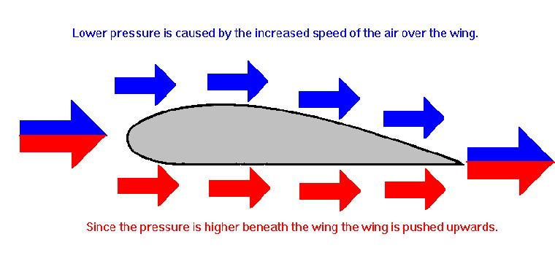

Name: _____________________________________

Adaptations of the Wingless Snakebird
Wingless snakebirds are found in remote desert areas where extreme heat makes wings and feathers a liability for survival. Snakebirds fly by expelling trapped air to soar over the desert terrain while searching for scorpions, insects, and other small critters to eat. The longer and more stable their flight, the more likely their hunt will be successful. In some areas of the desert southwest, striped snakebirds (invasive) are competing with solid snakebirds (native) for the limited resources found in these remote areas.
In this important investigation, your job is to conduct an experiment that will allow you to observe, measure, and compare how the adaptations of these two species of snake birds impacts the flight (and survival) of these critters.

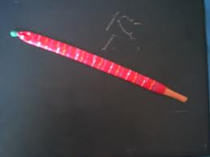

Observations: Describe the physical characteristics and movement of each snakebird.

Solid Snakebird | Striped Snakebird

Data:
Trial | Solid Snakebird  Flight Time | Solid Snakebird  Flight Distance (Steps) | Striped Snakebird  Flight Time | Striped Snakebird  Flight Distance (Steps)
1
2
3
Average
Calculate Average: Trial 1 + Trial 2 + Trial 3 = Total Total/3 = Average

Results: On a separate sheet of paper, construct a bar graph displaying the above Flight Time data for each snakebird.

Analysis: On a separate sheet of paper, write an analysis (at least a paragraph) explaining which species is most likely to survive and prosper based on the data you obtained.

